**Putty:**

-- IP address is shown; you could also use dba120.abtech.edu as the Host Name

-- **Save** the session as RemoteServer (or whatever you want)

-- change the Window/Appearance to be a different font (if you want)

-- change the Window/Colours to system colours (if you you want)

-- return to the Session/Logging screen and make sure to click Save again to get all changes

-- either double click the Saved Session Name or select it and Open

-- click ‘Yes’ if asked about a “Potential Security Breach”

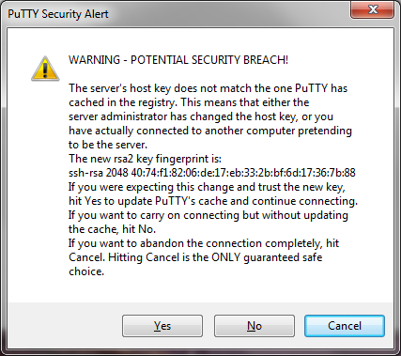

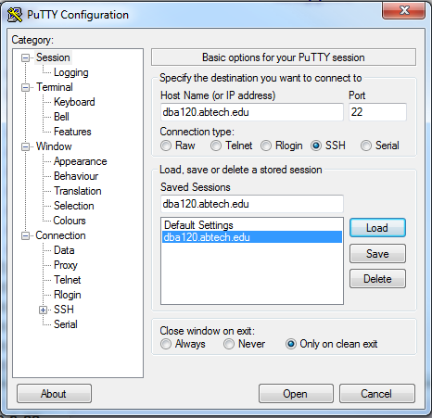

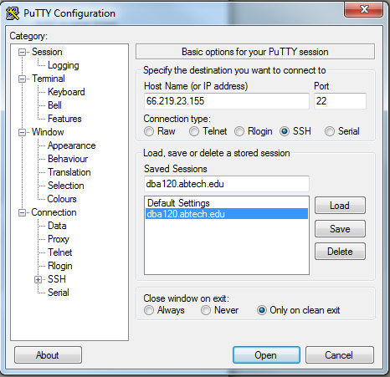

Log on to Linux with username of _heathermoore_____ and password of ___hmoore_9061_____________

When you log on to the server, you are (by default) in your home directory!

This username and password will be the same for your MySQL login.

**ls** list the directory contents

**cd** change into **your** home directory

**cd /**  change to the root directory

**cd ..** go back a previous/parent directory

**cd /home** get to **the** home directory

Where are you? (**pwd**) __heathermoore@dba120:/home$___________________

Practice with each cd command. After each one, issue the pwd to verify you are where you thought you would be.

in **the** home directory, **ls** to see the contents **can you see other student’s directories? _yes____ Can you change into another student’s directory? _no___

do you see a directory named student_files? _yes_____ can you get into that directory? _yes___ can you list the contents? _yes_____

If you want to know more about a command, for example the *ls* command, you type **man ls**. A rather wordy explanation will be returned as indicated below.

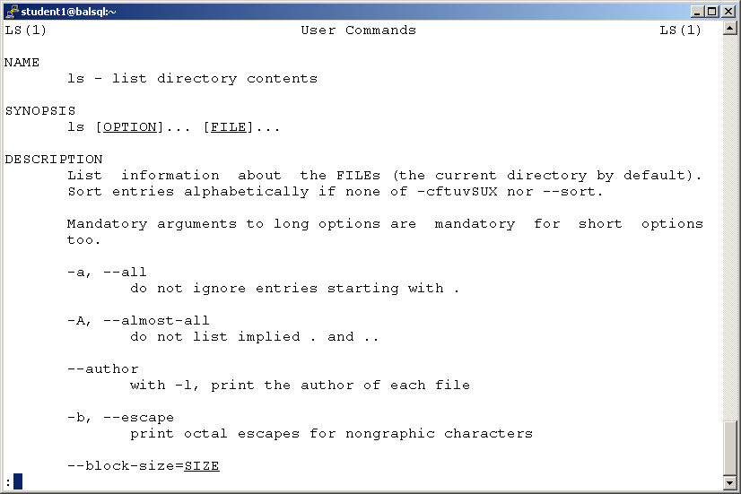

At the bottom of the screen, you may see a colon (:) – press **Enter** to continue with the information one line at a time, press **spacebar** for a page at a time, press **b** to go back to the prior contents, or press **q** to return to the linux prompt.

For a one line explanation, use whatis. For example, if you type in **whatis ls**. You will receive the following:

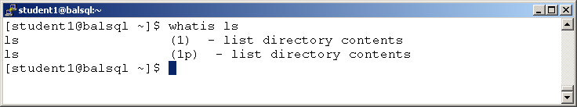

What if you don’t know the name of a command, search with apropos using a keyword. The keywords are listed in the whatis database. For example, you want to know how to create a user. Type **apropos user** – see the contents fly by! If you type **apropos user | less** you will get the info page by page.

**Linux Links: (These are to help you gets started, you should search for a Linux cheat sheet that you like)**

[htthttps://www.lifewire.com/beginners-guide-to-linux-4090233p://linux.about.com/](http://linux.about.com/)

<http://www.computerhope.com/unix/overview.htm>

<http://www.computerhope.com/unix.htm>

**Copy and paste activity – using help options**

**Commands to know and love in Linux:**

|  |  |
| --- | --- |
| Command | Explanation |
| Ls | lists files and directories within the current working directory |
| clear ctrl l | clears the screen |
| Date | shows current date and time |
| Rm | remove files or directories |
| Who | get the information of currently logged in users |
| whoami | show who you are logged in as |
| Echo | allows a user to repeat a string variable to standard output |
| Last | shows last logged in users |
| More | pages through text one screen at a time, but is more limited in moving in files |
| Less | displays text files one screen at a time, with backward and forward moving available in files |
| !! | repeat last command |
| ! letter | run last command starting with that letter |
| Cat | command that can read, modify, or concatenate text files, most commonly used for displaying the contents of a file |
| up/down arrows | scrolls through most recently entered commands |
| History | shows all of the last commands that have been recently used |
|  |  |
|  |  |

**cd student_files** – to change into the student_files directory inside the home directory

**ls** to see the contents of the student_files directory

wildcard characters –

what command will you use:

**__ls *.sql__________** – to see just the .sql files

**__ls *.txt__________** – to see just the .txt files

Creating and copying a few files from the student_files directory into your home directory:

Choose three files and copy them …. Try using just one command with a wildcard.

What command did you use:

cp *.txt /home/heathermoore_______ .